“Our Safety is everybody’s responsibility!”

“Just this once” and “We’re running late today” are NOT valid excuses.
“Our Safety is everybody’s responsibility!”
If everyone uses the pavement, access roads and car parks properly, then we will greatly reduce the risk of an accident.

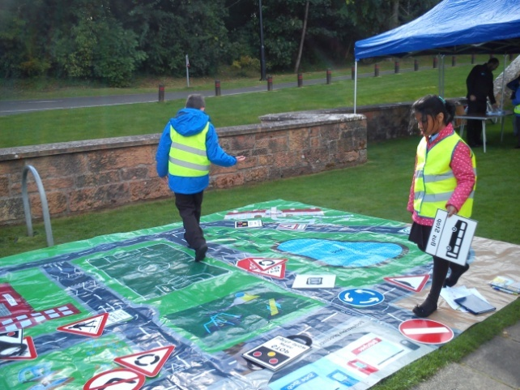

Police Message
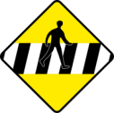
“Inconsiderate parking at schools is a major safety issue for both the police and the school pupils of South Lanarkshire. Most parents are fully aware of the problems and dangers that inconsiderate parking can cause, therefore we urge parents and driver to adhere to the rules and respect the safety of the children at all times.”
Hamilton Community Police

St Mark’s Primary School, Hamilton

Our Guide
to Parking Safely

Junior Road Safety Officers:
Minahil Imran and Ronan Gemmell

Primary 5/6

Who are we?
We are the Junior Road Safety Officers (JRSO) within St Mark’s Primary School. We are responsible for making sure everyone is aware of how to stay safe on or near roads. Our responsibility is not only to teach the pupils of our school about this important topic, we also teach their parents too!

Drop Off Zone
‘Dropping and Stopping’ for a safe entry and exit to school.

Please adhere to the following rules to ensure the safety of all children:
- Do not exceed 5 mph when driving on the school grounds
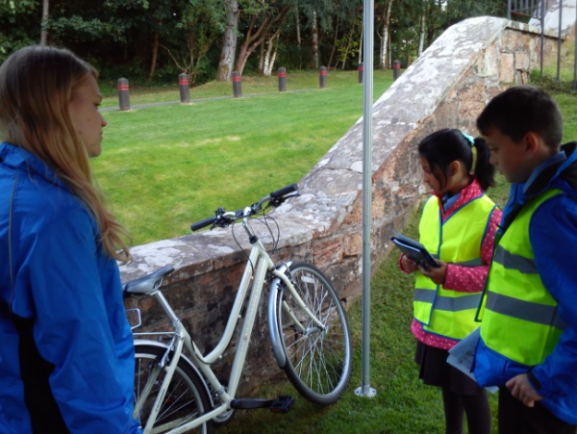
- Please use the drop off area but do not leave your car parked here
Let’s all work together to make the
School Entrance a safer place to be!
- Do not leave your car to chat to others
- Your child should always exit the door nearest the pavement with school bags and lunch boxes
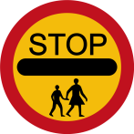
- Do not park in the disabled parking area, unless you have a badge to do so
- Do not park on the road at the school entrance, this must be kept clear at all times

Walking and Cycling to School
The healthiest way to travel to school is to walk, scoot or cycle. If your child comes to school on foot, by scooter or bicycle, then you need to make sure that your child has a cycle helmet, high visibility vest and knows the correct route to school, safely. Children and adults should not walk through car parks; they should use the foot paths and should only cross roads properly using traffic lights, zebra crossing, our lollipop man and always remember the Green Cross Code.
Did you know?
Walking to and from school can contribute to your child’s one hour of moderate activity a day as recommended by the British Heart Foundation.

“Stop, drop and Drive!”
Keep the traffic moving in our very busy school car park!

